**Project Design Phase-II**

**Technology Stack (Architecture & Stack)**

|  |  |
| --- | --- |
| Date |  |
| Team ID | LTVIP2025TMID59401 |
| Project Name | SmartSDLC – AI-Enhanced Software Development Lifecycle |
| Maximum Marks | 4 Marks |

**1.Overview**

The SmartSDLC platform is designed using a modular microservice-style architecture. The system includes a browser-based frontend, Python-based backend APIs, and integrates large language models (LLMs) for intelligent automation of SDLC tasks. The platform is cloud-compatible and can scale vertically or horizontally depending on deployment configurations.

**2. Architecture Overview**

The architecture comprises the following components:  
- User Interface (UI): Built using Streamlit for interactive, real-time user experiences.  
- Backend Engine: Developed using FastAPI to handle routing, module invocation, and business logic.  
- AI Module Layer: Interfaces with pretrained LLMs (hosted locally or via IBM Cloud) to perform code generation, classification, and summarization.  
- Input/Output Processor: Manages file parsing (e.g., PDF extraction) and formatting of results.  
- Optional Cloud Layer: Supports deployment on IBM Cloud with auto-scaling and persistent storage.

**Figure: SmartSDLC System Architecture Diagram**

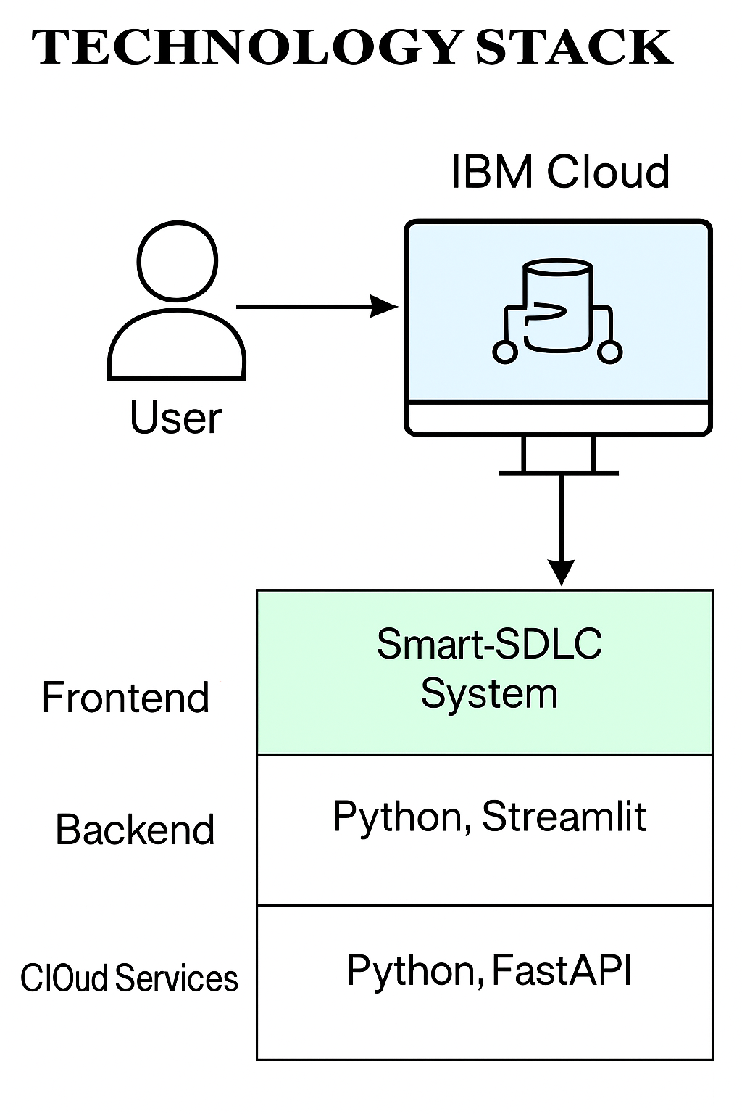

**3. Component-wise Technology Stack**

|  |  |  |
| --- | --- | --- |
| **Component** | **Technology Used** | **Purpose** |
| Frontend | Streamlit (Python) | User interaction & display |
| Backend | FastAPI / Flask | Routing & feature orchestration |
| PDF Processor | fitz (PyMuPDF) | Extracts and parses requirement documents |
| AI Model Layer | OpenAI API / IBM Watson / LLMs | Performs code generation, summarization, classification |
| Authentication | IBM IAM or OAuth | Secure API and data access |
| Deployment | Docker + IBM Cloud (optional) | Scalable and portable deployment |

**4.Components & Technologies**

|  |  |
| --- | --- |
| **Components** | **Technologies** |
| Frontend | Python, Streamlit |
| Backend | Python, FastAPI |
| Cloud Services | IBM Cloud |

**5. Technical Merits**

- Highly modular architecture supporting plug-and-play AI models.  
- Lightweight frontend with quick startup and interactive experience.  
- Designed to be extensible for future use cases like CI/CD automation.  
- Easily portable across local, cloud, or hybrid environments.